8 August, 2026
Today’s topic-
Master details relationship:
- 1. Master is mandatory while creating details records
- 2. When we delete master record details gets deleted cascading.
- 3. While creating m-d relation, no record exits in detail object
- 4. We can create rollup summary field of master object of detail record.
Object – “applicant”- master object
Object – “address” – detail object
We will form object relationship between them

Point 1. Master is mandatory while creating details records
Step 1: creating another object “address”
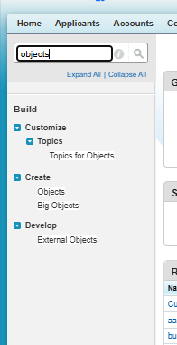
Step 2
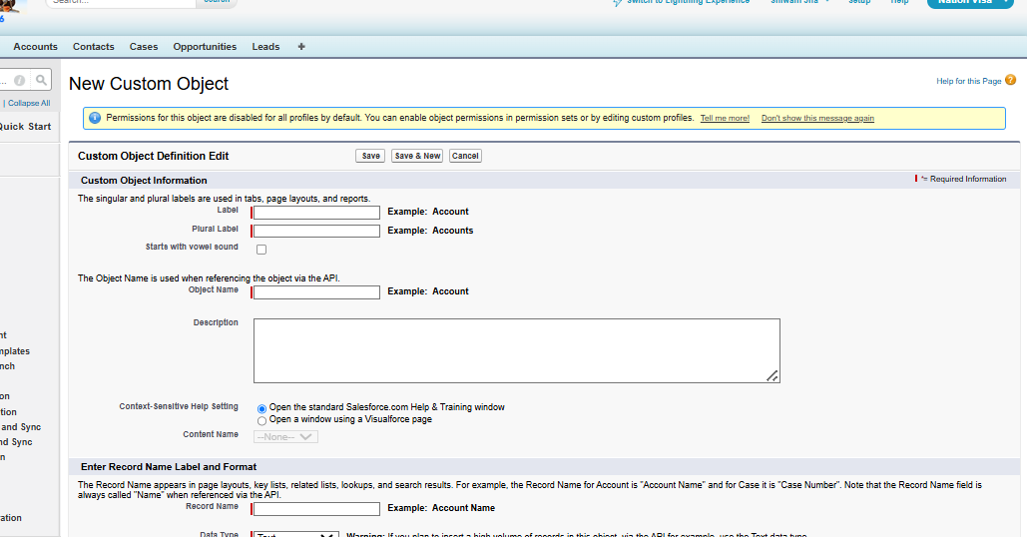
Step 3: On the AutoNumber
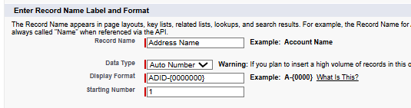
Step 4: Tick all
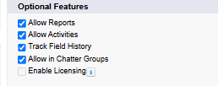
Step 5: tick the last one to get your object on your tab directly.
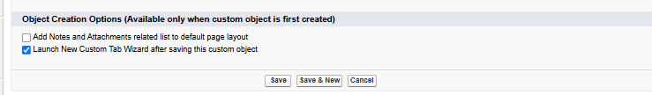
Step 6: form check
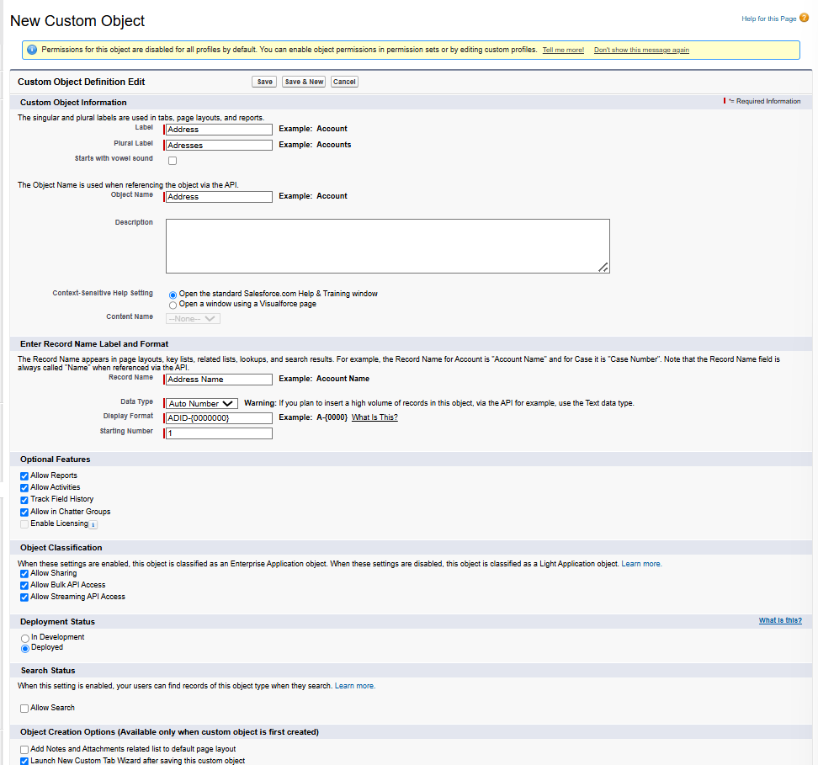
Step 7: New tab for new object
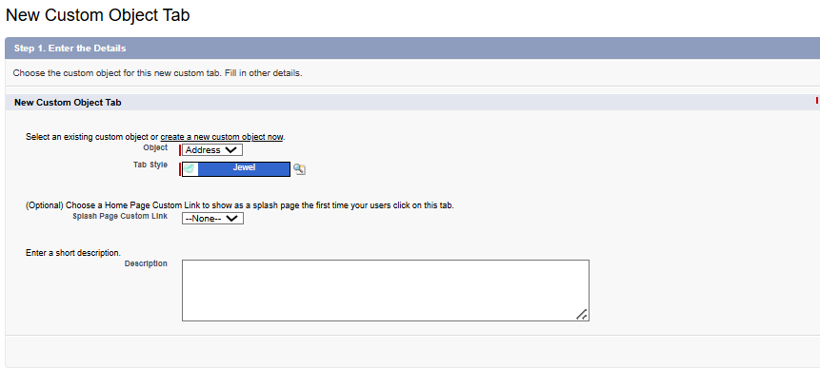
New object created- “Address”
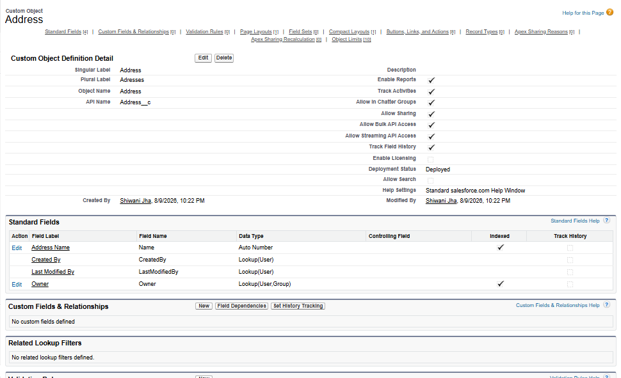
Adding fields in this object according to BRD given-
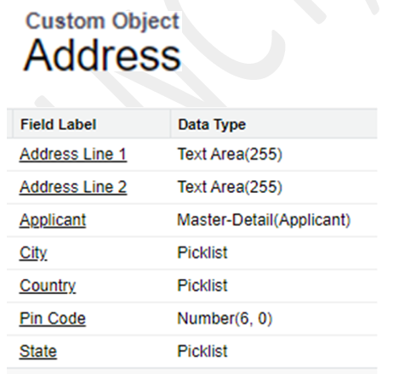
Same process like previous, Create “Adress line 1”, “Address line 2” and “pin code” fields only right now.
Steps to create master- detail relationship between the objects:
Step 1: Always remember to create the master-detail relationship from detail object.
“Address” object-
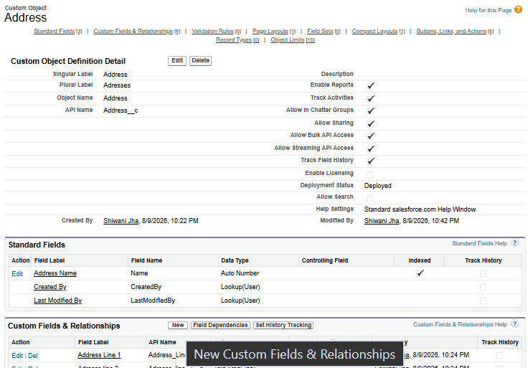
Click on “New” from Custom fields and relationships.
Step 2: create a master detail relationship
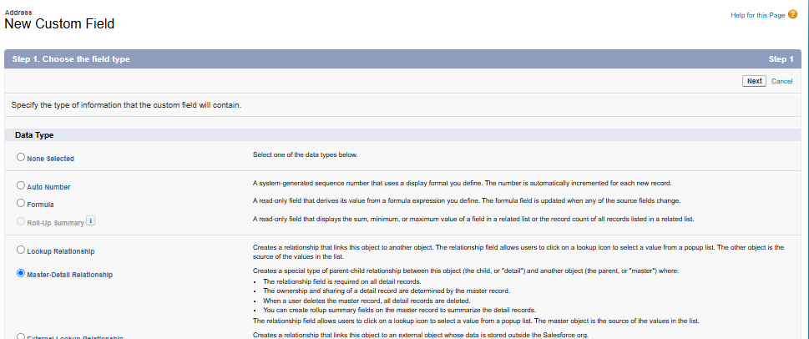
Step 3: Choose the master which is here – “Applicant”
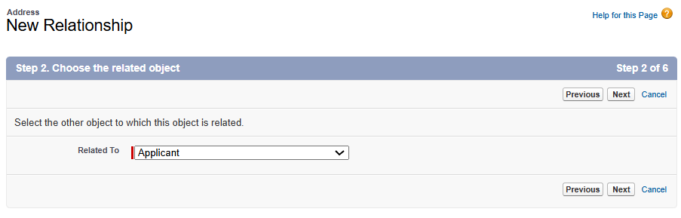
Click on next- next- next and save.
Result-
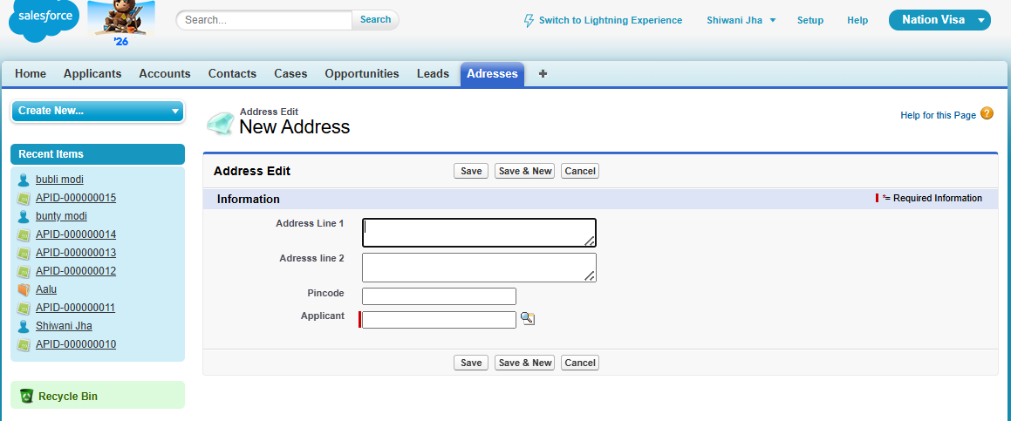
First point: For a Master-Detail relationship, the Master (Applicant) is important because it is required.
Fill the data from this search and select the applicant.
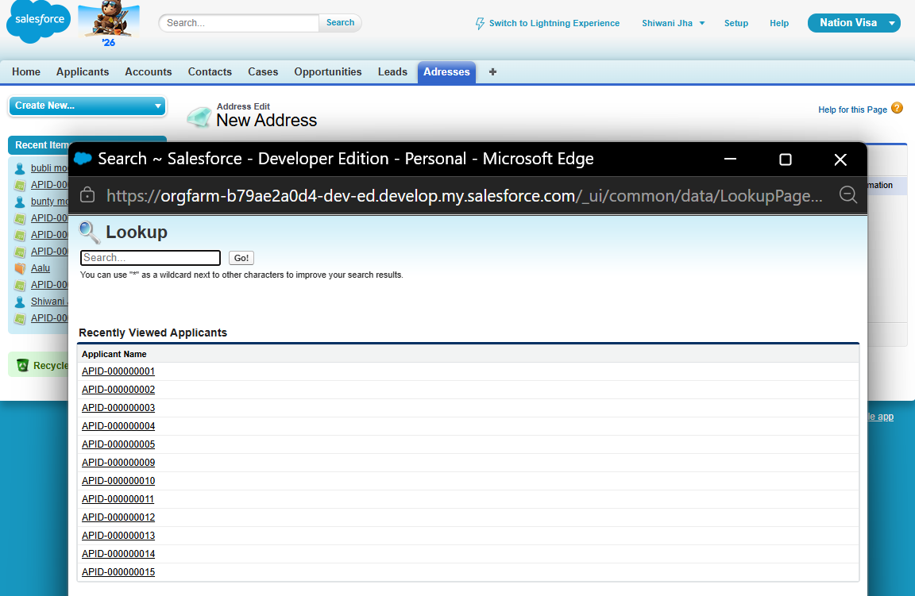

To edit this, we need to change the Applicant layout.
Step 1: “Search Layouts” in the Applicant object.
Open Applicant object-
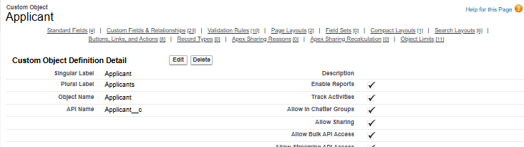
Scroll down-
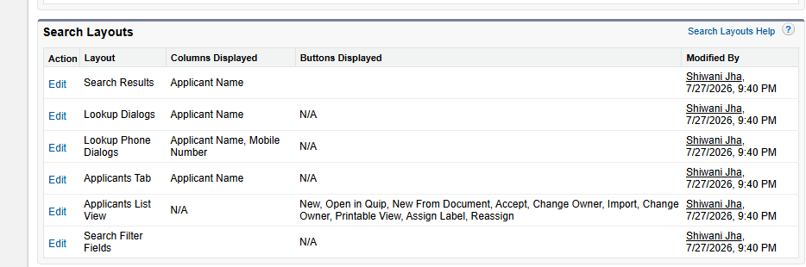
This is visible because we checked “Allow Search” while creating the object.
Step 2: Click on “edit” of Lookup Dialogs
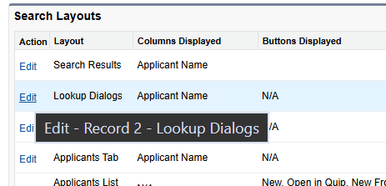
Step 3: Add the fields that you want to show in the lookup- like first name, last name and gender.
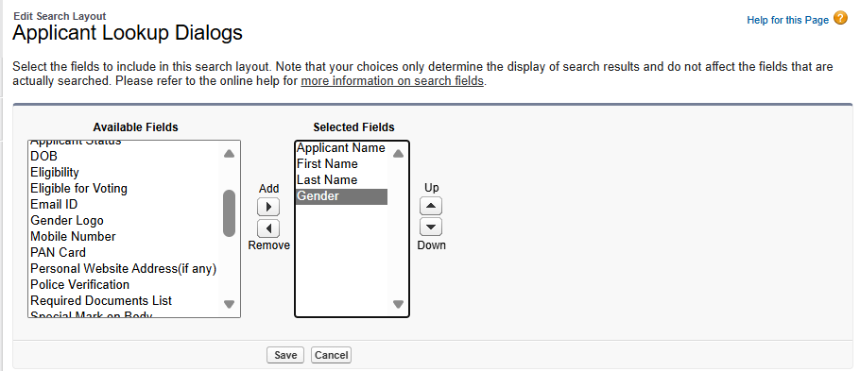
Result:
New look-
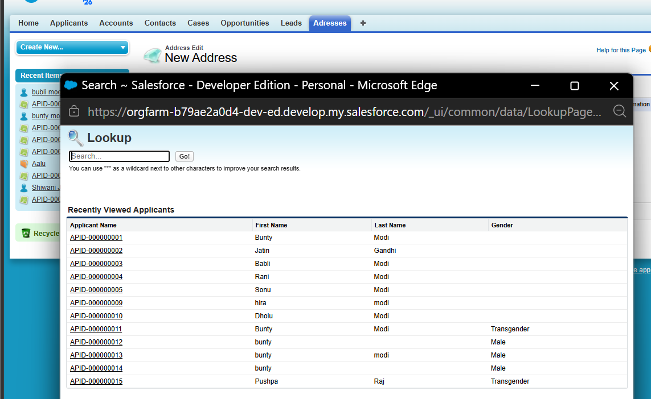
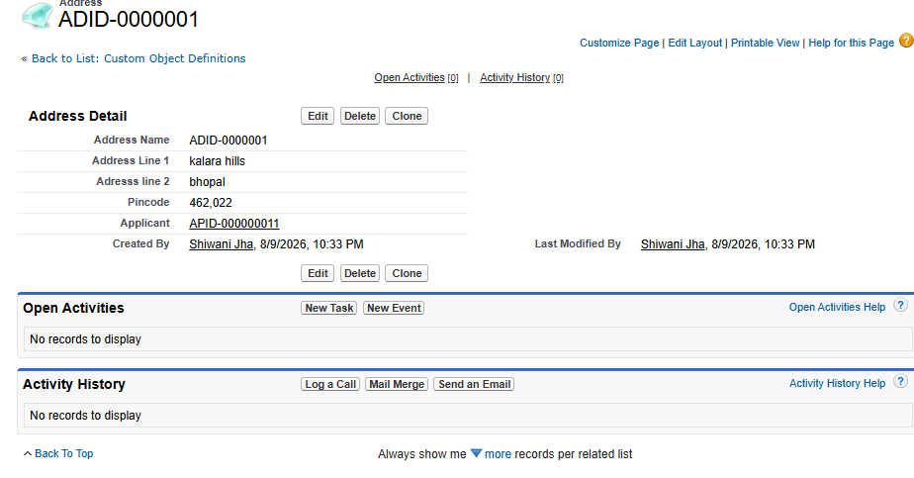
User story – 1:
Add related list sections for address at bottom
Will do it with the help of “Page layout”.
See in the image below for address there is no section – which tells its address lin1 , 2 or pincode.
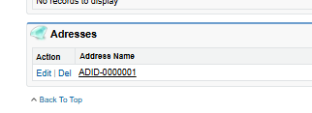
Now will edit the page layout of applicant.
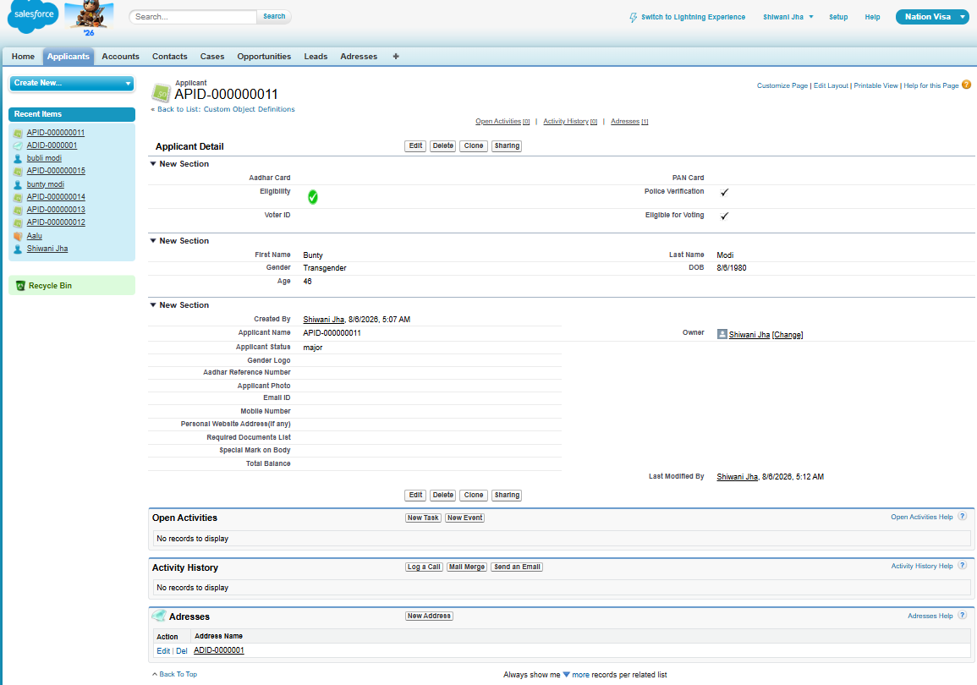
Step 1: Click on “edit” of Applicant layout from Applicant object.
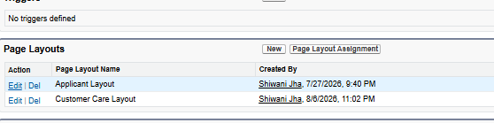
Editing the Related lists
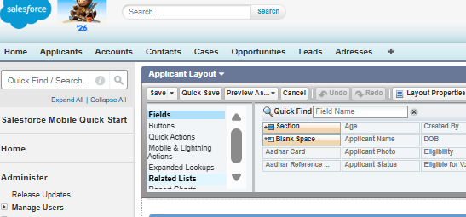
Step 2
Click on this of Addresses
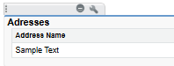
Step 3
Add the field which you want.
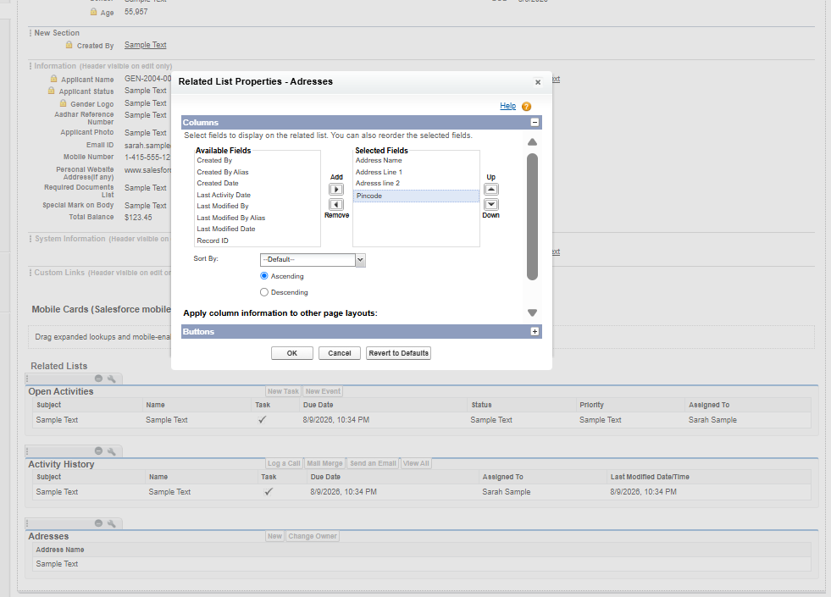
After adding-
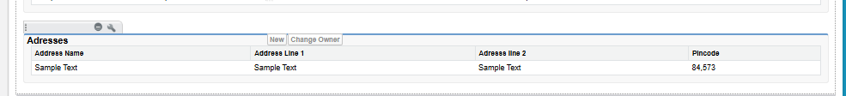
Result of Applicant-
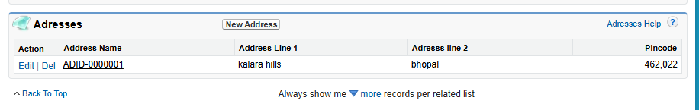
Clone the address- add one more. Then it will show as many addresses of same applicant.
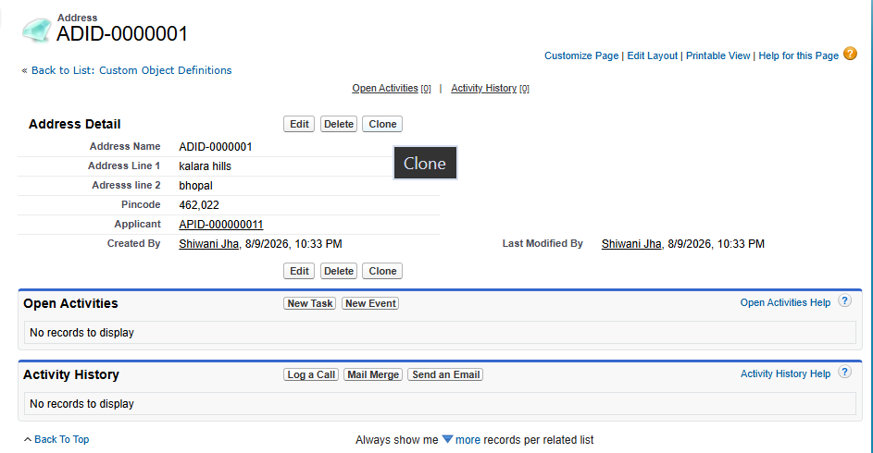

New address with id-2
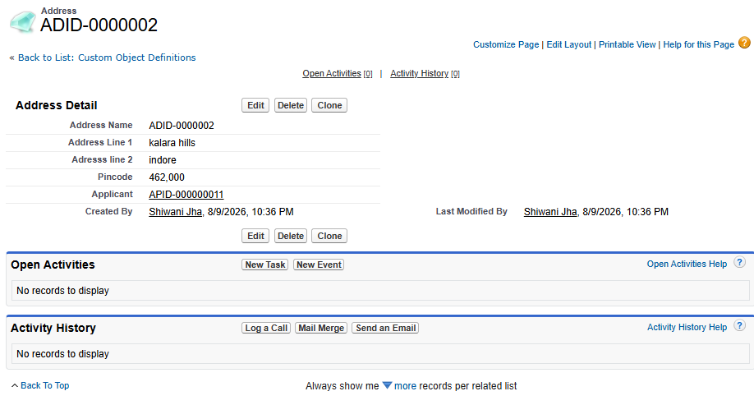
Applicant – 11 has two addresses.
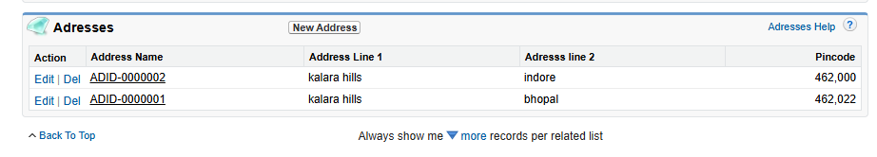

Point 2: When we delete master record details gets deleted cascading.
Step 1
Delete the applicant
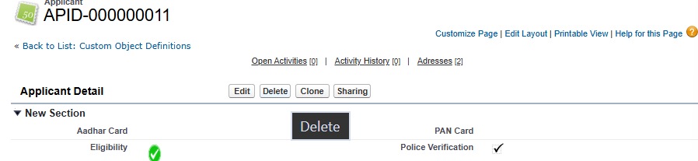

Address gets deleted automatically-
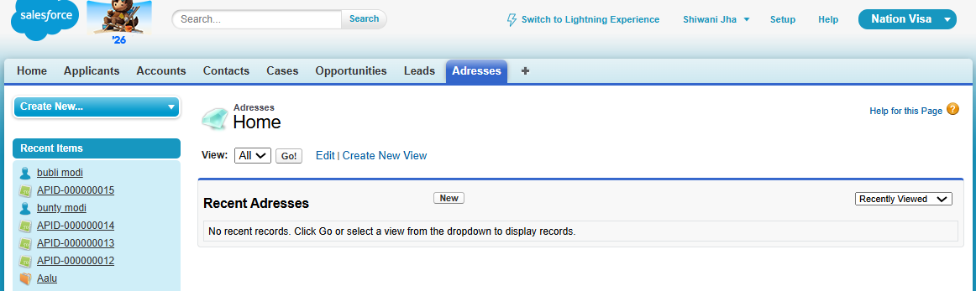
From Recycle-Bin , Restore the applicant again
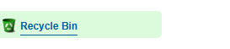
Now, the Address records will also come back because you have undeleted the Applicant.

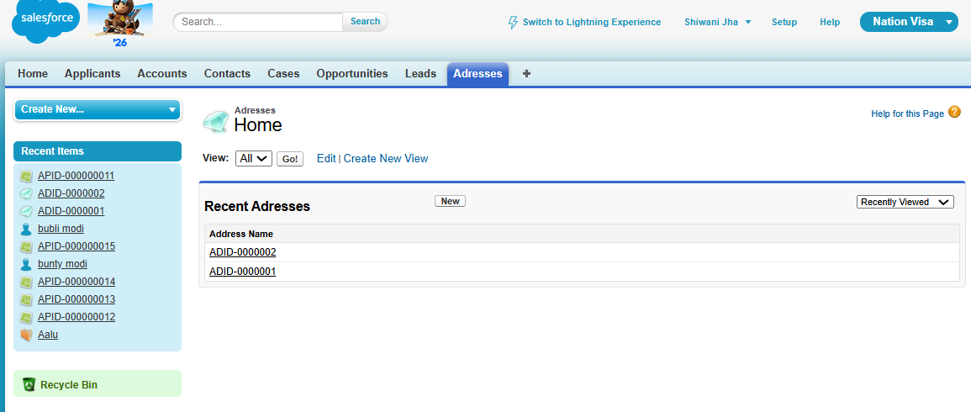
The Address record came back because we undeleted the Applicant from the Recycle Bin.

Point 3: While creating Master-Detail relation, no record exits in detail object
Let’s first delete the existing Master-Detail relationship. However, the records in the Detail object (Address) will still be there. We will then try to create a Master-Detail relationship between Applicant (Master) and Address (Detail), but it will not be possible because the Detail object already contains records and that proves our 3rd point.
Step 1
Delete the master-detail relationship from “address” object
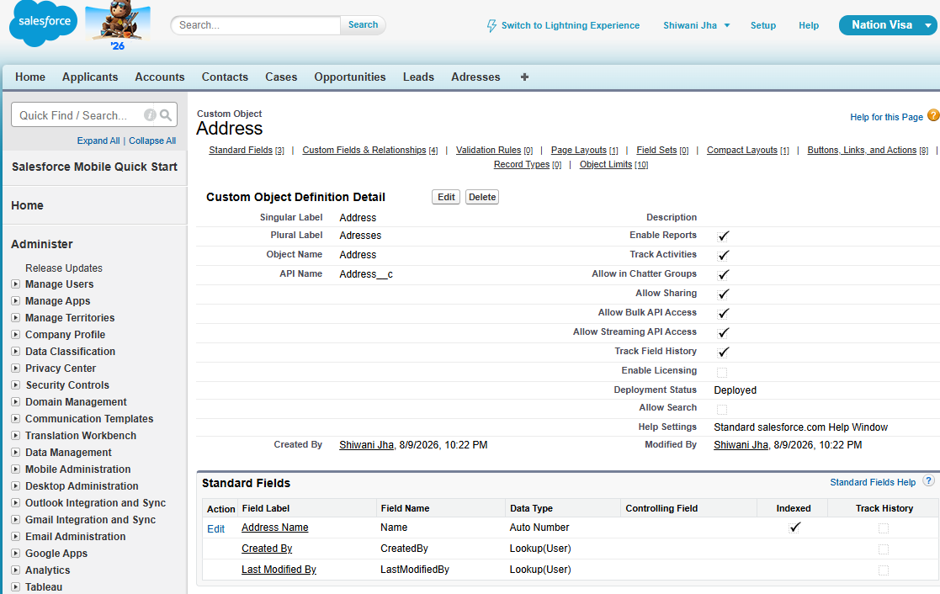
Step 2
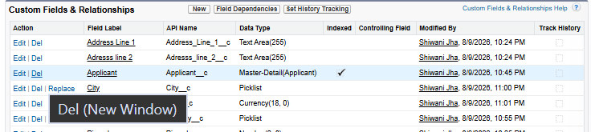
Step 3
Check the detail object- “address” still has the old data.
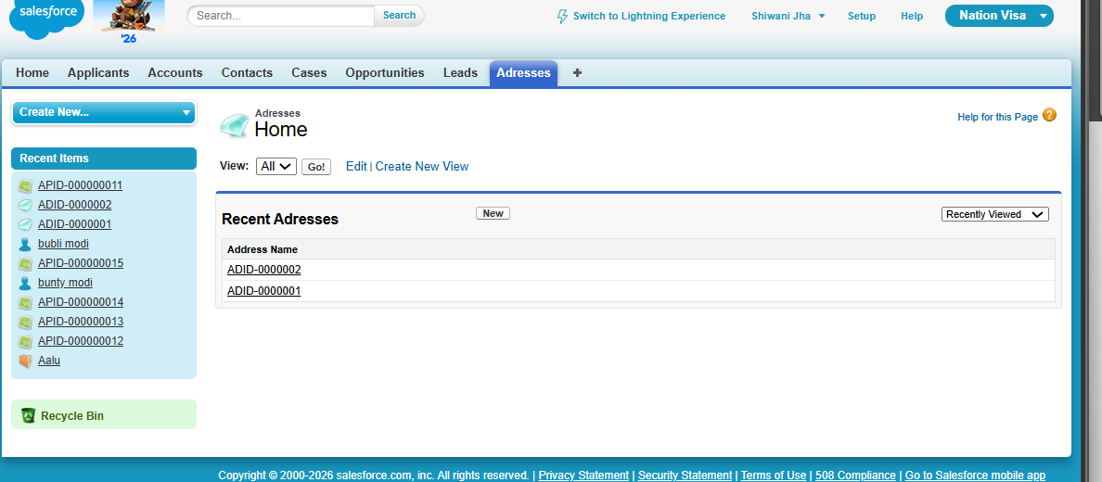
Step 4
Creating new master-detail relationship.
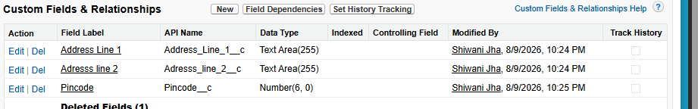

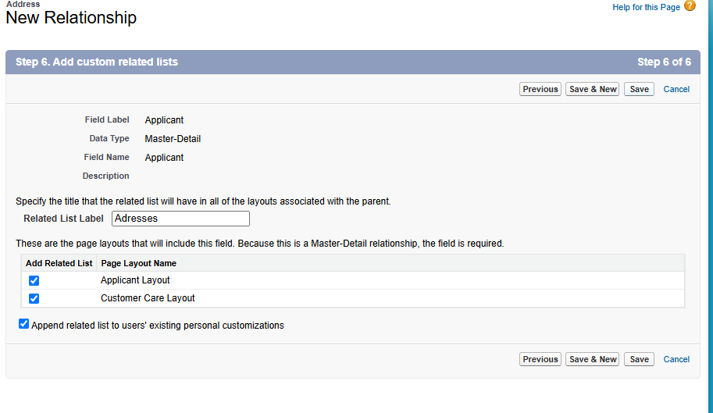
Click Next → Next → Next → Save.
An error message will appear.
The message clearly states that you cannot create a Master-Detail relationship because records already exist in the Detail object.
We will later follow Salesforce’s suggestion to first create a Lookup relationship.

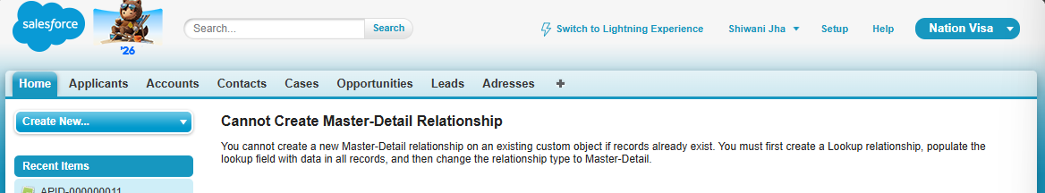

Right now, solution- delete the records and try again to create.
Delete records-
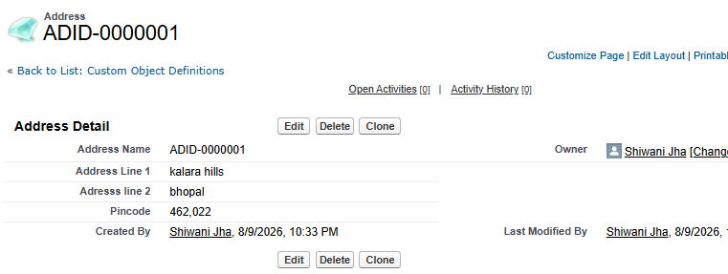
Deleted all the records.
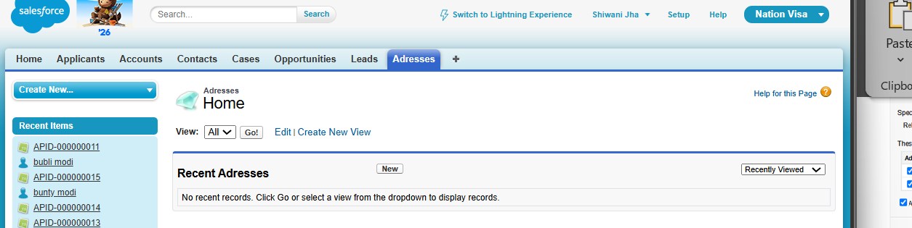
Now add the Master-Detail relationship, as there are no records in the Address object.
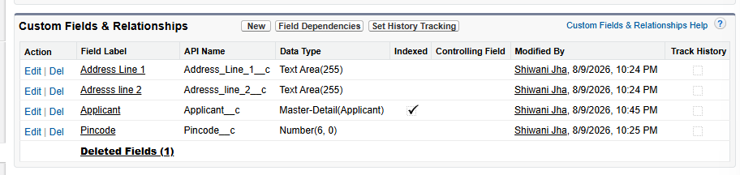
Don't try to undelete the records. Salesforce is smart enough to have already removed them from the Recycle Bin.
Recycle bin is empty.
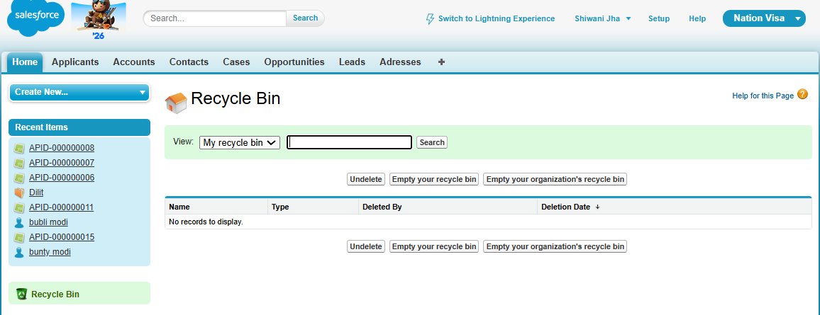

Point 4: We can create rollup summary field of master object of detail record.
Roll up summary
A.name | Address city | Plot cost
Kabira speaking | Bhopal  Indore  Pune  Pune  Delhi | 500  1500  1000  2000  2500

Max, min, sum, count are only supported by salesforce.
Average by sum/count
Total plot cost- 3500
User story 2:
Steps to create the fields that counts the number of cities and cost of plot of all or specific region.
Step 1
Create the fields of country, state, and city.
Country field- “picklist”
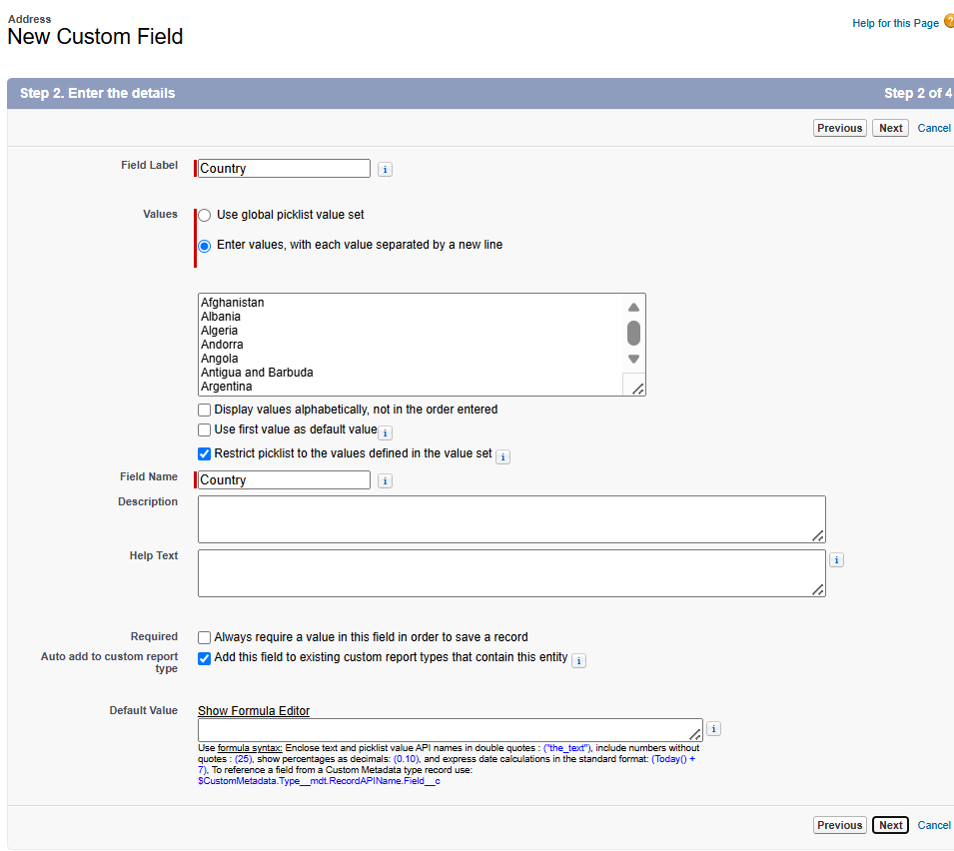
States field- “picklist”
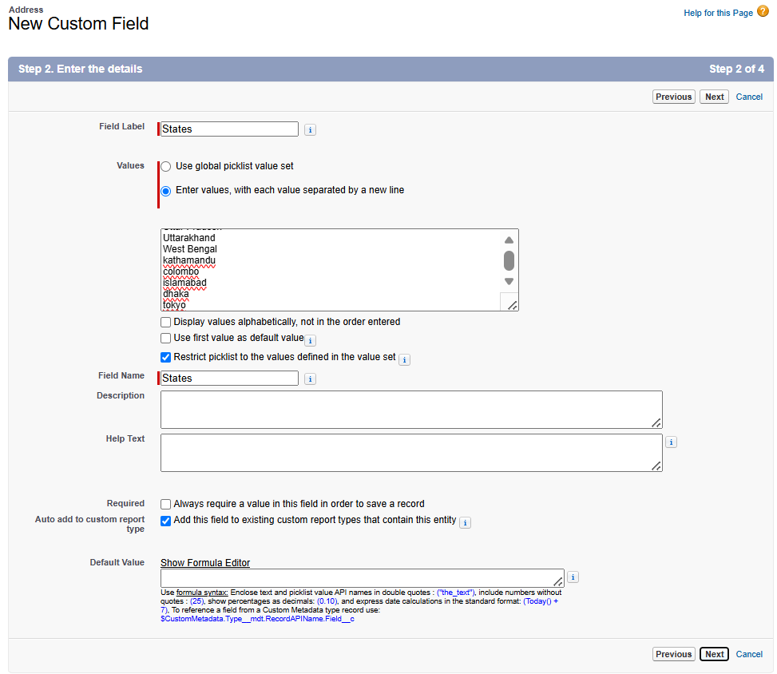
City field- “picklist”
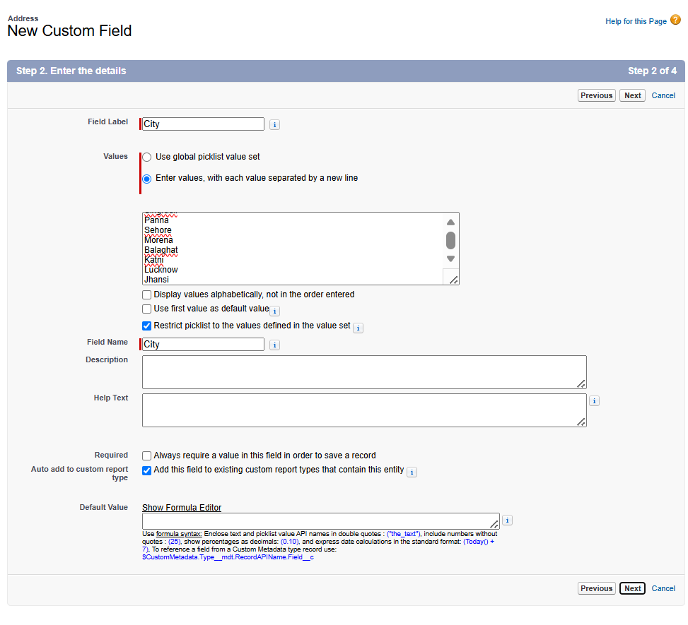
Step 2
Create the cost field- choose “Currency”
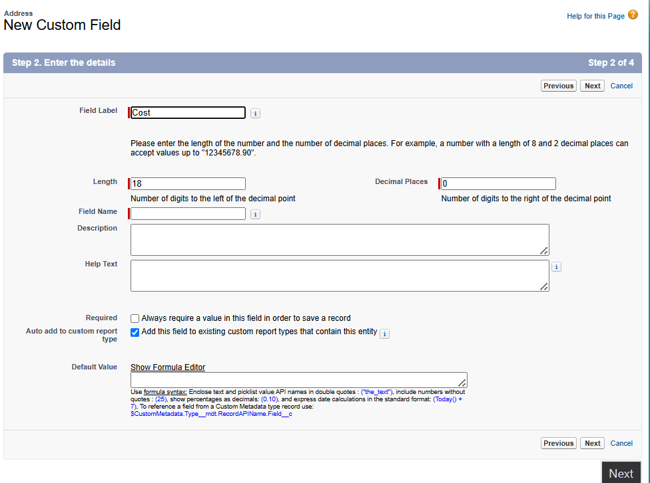

Steps to change the layout of the related lists-“addresses”
Again, from page layout method, click on applicant object-> layout -> applicant layout-> edit -> click on this of address section and add the fields which you want to show. Here we are adding cost and city.
Layout change-
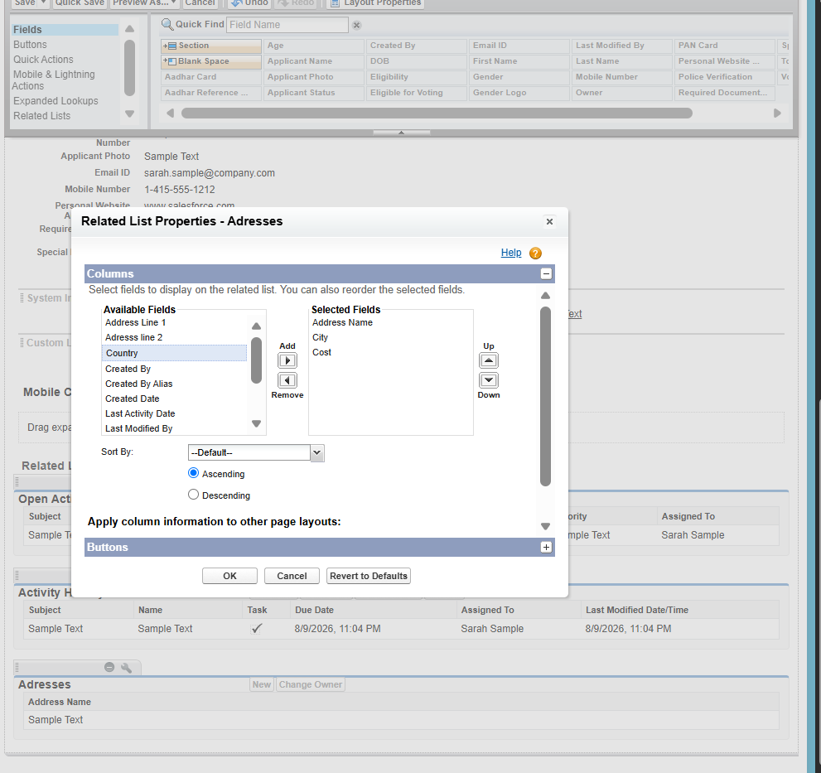
Result-
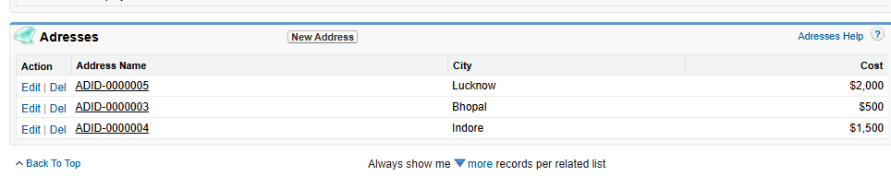
Note: The Roll-Up Summary field will be created on the Master object.
Step 1
Open applicant object -> custom fields -> create the field -> “new”
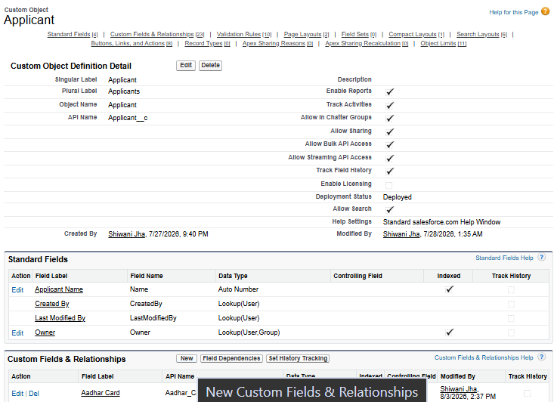

Step 2: Click on this-

Step 3: Select the “rollup summary”
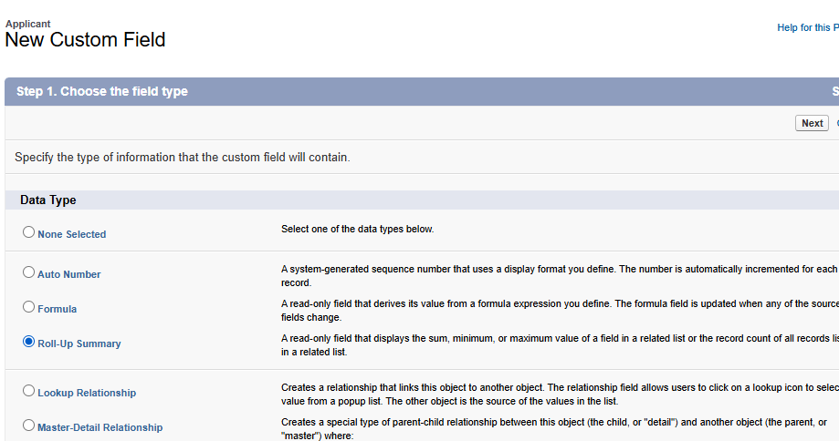

Step 4: Create fields for “Count of city”
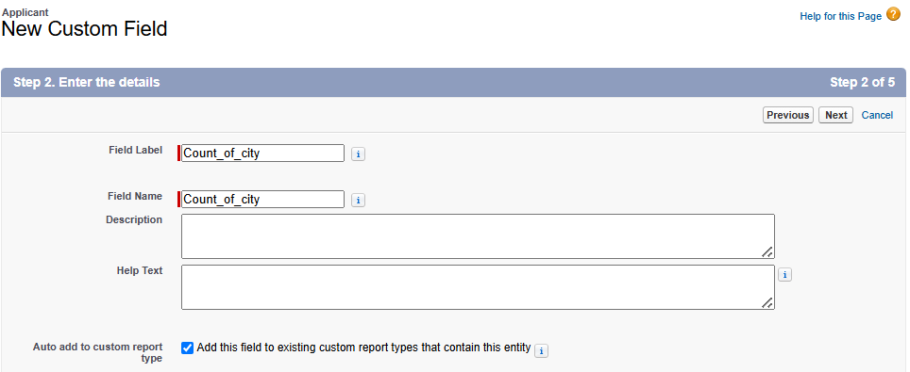
Step 5: next- next – save.
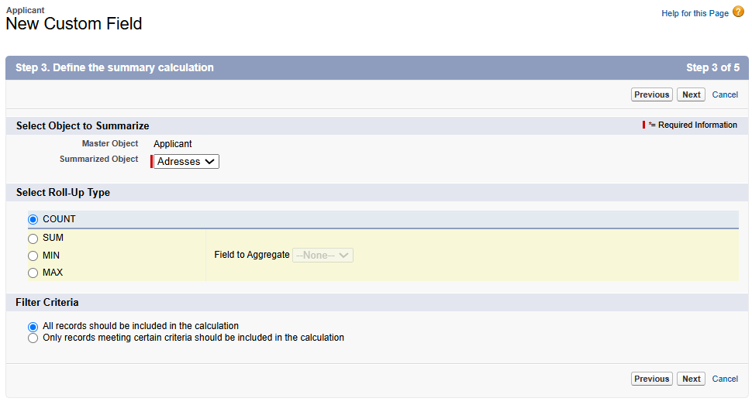
Result
Before-
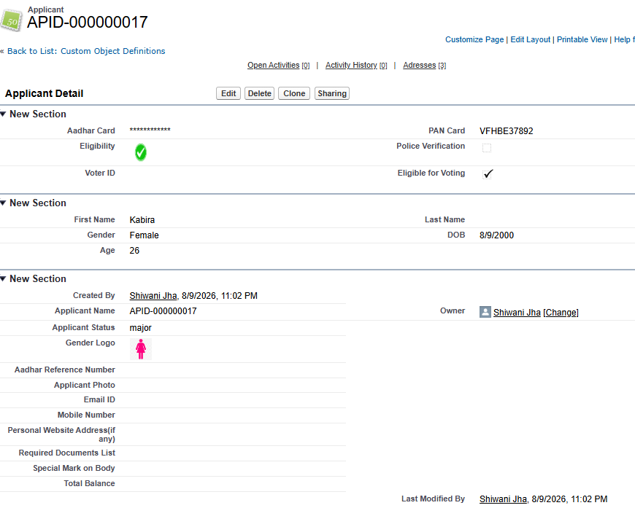

After-
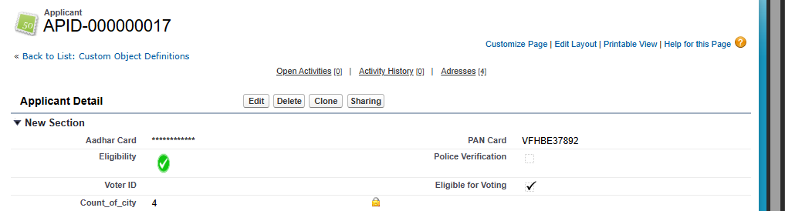

Testing
Deleted the address 1 and check the count-
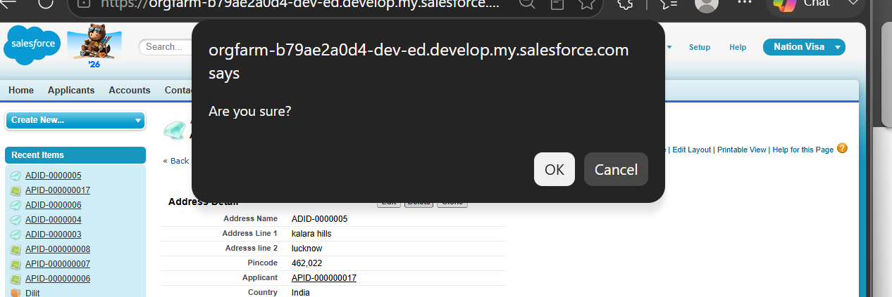
Result-
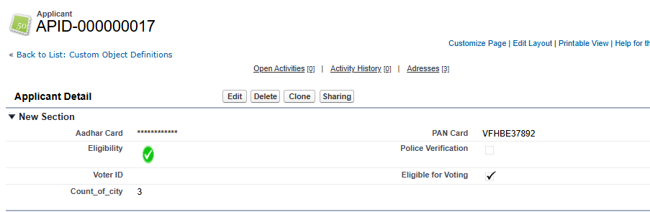
Add new and check the count. Undelete from recycle bin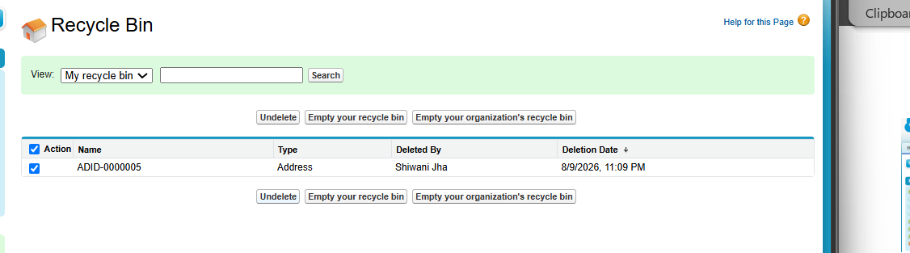Now check-
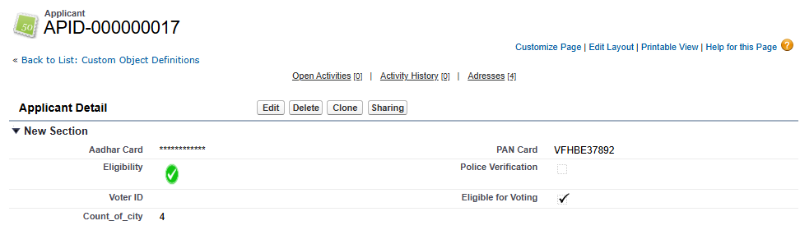
User story 3: Create a field to show the plot cost of specific region. Like- plot_cost_of_bhopal
Step 1
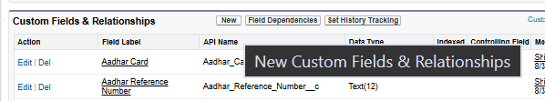
Step 2
Step 3
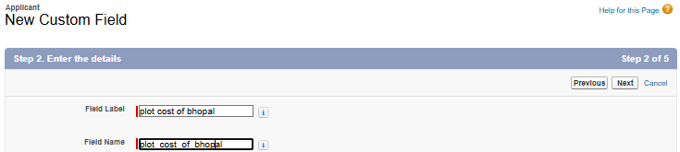
Step 4
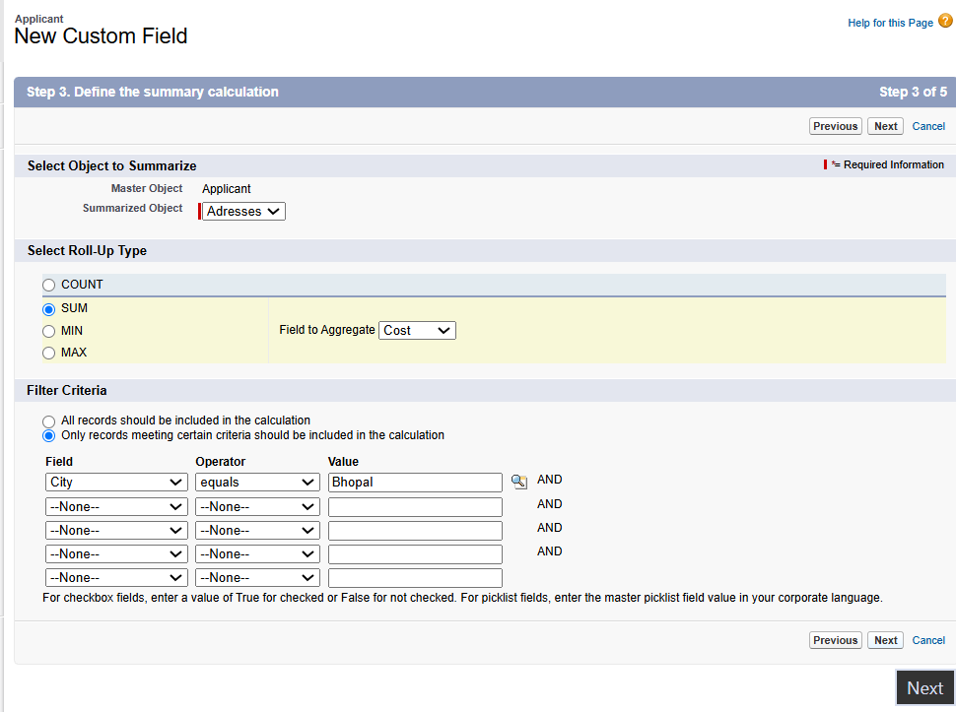
Result-
